**SubSpaces**

A subset W of a vector space V is called a subspace of V if W is itself a vector space under the addition and scalar multiplication defined on V.

**Subspace Criteria:**

If W is the subset of a vector space V, then W is called subspace if and only if the following conditions hold:

1. (Closed under addition) If $\vec{u}$ and $\vec{v}$ are vectors in W, then $\vec{u}+\vec{v}$ is in W.
2. (Closed under scalar multiplication) If k is any scalar and $\vec{u}$ is any vector in W then $k\vec{u}$ is in W.

Or in other words, W is subspace of V if and only if it is closed under addition and scalar multiplication.

**Example 1:** If V is any vector space and if $W=\{\vec{0}\}$ is the subset of V that consists of the zero vector only, then W is closed under addition and scalar multiplication since

$$\vec{0}+\vec{0}=\vec{0}$$

$k\vec{0}=\vec{0},$ for any scalar k

We call W the zero subspace of V.

**Example 2:**

$$W=\{\left(x,y\right);x≥0, y≥0\}$$

Prove and disprove W is subspace of $R^{2}.$

Solution:

1. W is closed under addition, because

Let, $\vec{u}=\left(x, y\right), \vec{v }=\left(x^{'}, y^{'}\right)∈W$ $(x,y≥0 and x^{'},y^{'}≥0)$

$\vec{u}+\vec{v }=\left(x+x^{'}, y+y^{'}\right)∈W$ $(x+x^{'}≥0 and y+y^{'}≥0)$

1. W is not closed under scalar multiplication, because if

$$\vec{u}=\left(1,1\right)∈W$$

But $-\vec{u}=\left(-1,-1\right)∉W$

So W is not subspace of V.

**Example 3:**

Which of the following subset of $R^{2}$ with usual operations of addition and scalar multiplication are subspaces?



$W_{1}=\left\{\left(x,y\right);x≥0\right\}$

$W_{2}=\{\left(x,y\right);x≥0, y≥0\}$

$W_{3}=\{\left(0,y\right);y∈R\}$

**Solution:**

1. $W_{1}$ is closed under addition but not closed under scalar multiplication, because
$$Let \vec{u}=\left(2,3\right)∈W$$

$$and \left(-2\right)\vec{u}=-2\left(2,3\right)=\left(-4,-6\right)∉W$$

2. Done in example 2.

$W_{3}=\{\left(0,y\right);y∈R\}$

As $W_{3}=y-axis$ in $R^{2}$. To see whether $W_{3}$ is subspace , Let

$$\vec{u}=\left(0,u_{1}\right),\vec{v}=\left(0,v_{1}\right)∈W_{3}$$

$$\vec{u}+\vec{v}=\left(0,u_{1}+v_{1}\right)∈W_{3},$$

$W_{3}$ is closed under addition.

Let $\vec{u}=(0, u_{1})$, k is any scalar then

$$k\vec{u}=\left(0,ku_{1}\right)∈W_{3}$$

$W_{3}$ is closed under scalar multiplication.

$W_{3}$ is subspace of $R^{2}$.

**Example 4:**

Which of the following subset of $R^{3}$ with usual operations of addition and scalar multiplication are subspaces?

1. $W_{1}=$ All vectors of the form $(a, 0, 0)$
2. $W_{2}=$ All vectors of the form $(a, 1, 1)$
3. $W_{3}=$ All vectors of the form $\left(a, b,c\right)$ where $b=a+c.$
4. $W_{4}=$ All vectors of the form $\left(a, b,c\right)$ where $b=a+c+1.$
5. $W_{5}=$ All vectors of the form $\left(a, b,0\right)$.

**Solution:**

$W_{1}=\left\{\left(a, 0, 0\right);a∈R\right\}$

1. $W_{1}$ is closed under addition and scalar multiplication as:
$$\vec{u}=\left(a_{1}, 0, 0\right)∈W_{1}$$

$$\vec{v}=\left(a_{2}, 0, 0\right)∈W_{1}$$

$$\vec{u}+\vec{v}=\left(a_{1}+a_{2}, 0, 0\right)∈W_{1}$$

2. Let $\vec{u}=\left(a_{1}, 0, 0\right)∈W_{1}$ and k is any scalar, then

$$k\vec{u}=\left(ka_{1}, 0, 0\right)∈W_{1}$$

$W_{1}$ is subspace of $R^{3}$.

$W_{2}=\left\{\left(a, 1, 1\right);a∈R\right\}$

Let’s check the first property, i.e. $W_{2}$ is closed under addition.

Let

$$\vec{u}=\left(a_{1}, 1, 1\right)∈W_{2}$$

$$\vec{v}=\left(a_{2}, 1, 1\right)∈W_{2}$$

$$\vec{u}+\vec{v}=\left(a_{1}+a_{2}, 2,2\right)∉W_{2}$$

$W_{2}$ is not subspace of $R^{3}$.

$W_{3}=\left\{\left(a, b, c\right);b=a+c;a, b, c∈R\right\}$

1. $W_{1}$ is closed under addition and scalar multiplication as:

$$\vec{u}=\left(a_{1}, b_{1}, c_{1}\right)=(a_{1},a_{1}+c_{1}, c_{1})∈W_{3}$$

$$\vec{v}=\left(a_{2}, b_{2}, c_{2}\right)=(a_{2}, a_{2}+c_{2}, c_{2})∈W_{3}$$

Then $\vec{u}+\vec{v}=\left(a_{1}+a_{2}, \left(a_{1}+c_{1}\right)+\left(a_{2}+c_{2}\right), c_{1}+c_{2}\right)$

$$\vec{u}+\vec{v}=\left(a_{1}+a_{2}, a_{1}+a_{2}+c_{1}+c_{2}, c_{1}+c_{2}\right)∈W_{3}$$

So $W_{3}$ is closed under addition.

1. Let $\vec{u}=\left(a_{1}, a_{1}+c_{1}, c_{1}\right)∈W_{3}$ and k is any scalar, then

$$k\vec{u}=k\left(a_{1}, a_{1}+c_{1}, c_{1}\right)=\left(ka_{1}, k\left(a_{1}+c_{1}\right), kc_{1}\right)$$

$$=\left(ka_{1}, ka_{1}+kc_{1}, kc_{1}\right)∈W_{3}$$

$W_{3}$ is closed under scalar multiplication.

So, $W_{3}$ is subspace.

1. $W_{4}=$ All vectors of the form $\left(a, b,c\right)$ where $b=a+c+1.$

$$\vec{u}=\left(a_{1}, b_{1}, c_{1}\right)=(a_{1},a_{1}+c_{1}+1, c_{1})∈W_{4}$$

$$\vec{v}=\left(a_{2}, b_{2}, c_{2}\right)=(a_{2}, a_{2}+c_{2}+1, c_{2})∈W_{4}$$

Then $\vec{u}+\vec{v}=\left(a_{1}+a_{2}, \left(a_{1}+c_{1}\right)+\left(a_{2}+c_{2}\right)+2, c_{1}+c_{2}\right)$

$$\vec{u}+\vec{v}=\left(a_{1}+a_{2}, a_{1}+a_{2}+c_{1}+c_{2}+2, c_{1}+c_{2}\right)∉W_{4}$$

So $W_{4}$ is not closed under addition.

So $W_{4}$ is not subspace of $R^{2}.$

1. $W_{5}=$ All vectors of the form $\left(a, b,0\right)$.(Do it yourself)

**Example 5.**

Consider the unit square shown in the accompanying figure. Let W be the set of the form $\left[\begin{aligned}x \\ y\end{aligned}\right]$, where $0≤x≤1, 0≤y≤1$. That is W is the set of all vectors whose tail is at origin and whose head is a point inside or on the square. Is W a subspace of $R^{2}$? Explain.

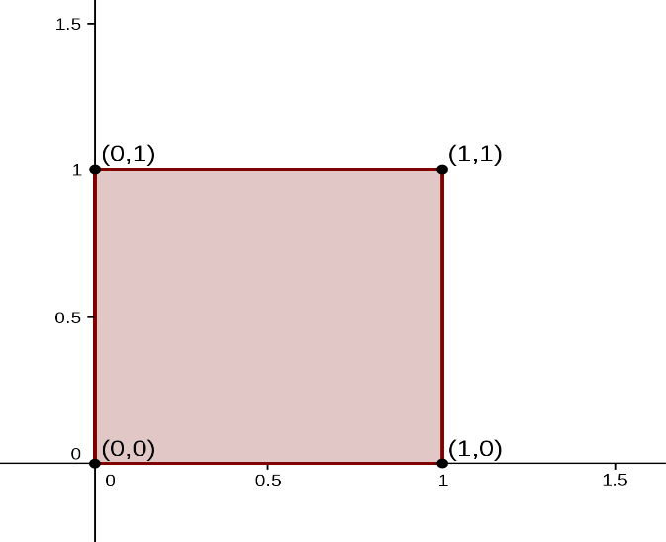**Solution:**

Let $\vec{u}=\left(0,1\right),\vec{v}=\left(1,1\right)∈W.$

Then $\vec{u}+\vec{v}=\left(1,2\right)∉W.$

W is not closed under addition.

W is not subspace of $R^{2}.$

**Example 6.**

Which of the given subsets of the vector space $M_{23}$ of all $2×3$ matrices are subspace? The set of all matrices of the form?

$W_{1}=\left\{\left[\begin{matrix}a & b & c \\ d & 0 & 0\end{matrix}\right];where b=a+c\right\}$

$W_{2}=\left\{\left[\begin{matrix}a & b & c \\ d & 0 & 0\end{matrix}\right];where c>0\right\}$

$W_{3}=\left\{\left[\begin{matrix}a & b & c \\ d & e & f\end{matrix}\right];where a=-2c, f=2c+d\right\}$

Solution:

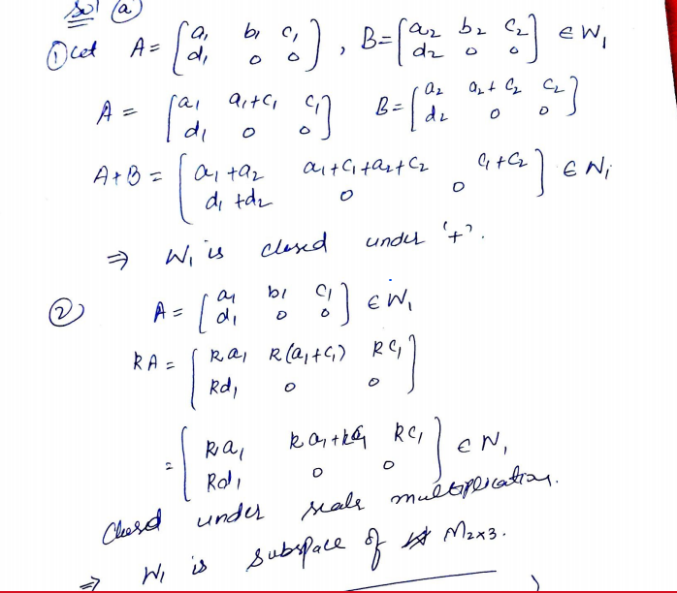

C: do it your self